Solution: Render a large list using FlatList

Overview
In this reading, you will review the solution code for the exercise.
The code block below outlines the outcome of the exercise in its entirety.

MenuItems.js
import React from 'react';

import { View, Text, StyleSheet, FlatList } from 'react-native';

const menuItemsToDisplay = [
{ name: 'Hummus', price: '$5.00', id: '1A' },
{ name: 'Moutabal', price: '$5.00', id: '2B' },
{ name: 'Falafel', price: '$7.50', id: '3C' },
{ name: 'Marinated Olives', price: '$5.00', id: '4D' },
{ name: 'Kofta', price: '$5.00', id: '5E' },
{ name: 'Eggplant Salad', price: '$8.50', id: '6F' },
{ name: 'Lentil Burger', price: '$10.00', id: '7G' },
{ name: 'Smoked Salmon', price: '$14.00', id: '8H' },
{ name: 'Kofta Burger', price: '$11.00', id: '9I' },
{ name: 'Turkish Kebab', price: '$15.50', id: '10J' },
{ name: 'Fries', price: '$3.00', id: '11K' },
{ name: 'Buttered Rice', price: '$3.00', id: '12L' },
{ name: 'Bread Sticks', price: '$3.00', id: '13M' },
{ name: 'Pita Pocket', price: '$3.00', id: '14N' },
{ name: 'Lentil Soup', price: '$3.75', id: '15O' },
{ name: 'Greek Salad', price: '$6.00', id: '16Q' },
{ name: 'Rice Pilaf', price: '$4.00', id: '17R' },
{ name: 'Baklava', price: '$3.00', id: '18S' },
{ name: 'Tartufo', price: '$3.00', id: '19T' },
{ name: 'Tiramisu', price: '$5.00', id: '20U' },
{ name: 'Panna Cotta', price: '$5.00', id: '21V' },
];

const Item = ({ name, price }) => (
<View style={menuStyles.innerContainer}>
<Text style={menuStyles.itemText}>{name}</Text>
<Text style={menuStyles.itemText}>{price}</Text>
</View>
);

const MenuItems = () => {
const renderItem = ({ item }) => <Item name={item.name} price={item.price} />;

return (
<View style={menuStyles.container}>
<FlatList
data={menuItemsToDisplay}
keyExtractor={(item) => item.id}
renderItem={renderItem}></FlatList>
</View>
);
};

const menuStyles = StyleSheet.create({
container: {
flex: 1,
},
innerContainer: {
paddingHorizontal: 40,
paddingVertical: 20,
flexDirection: 'row',
justifyContent: 'space-between',
},
itemText: {
color: '#F4CE14',
fontSize: 20,
},
});

export default MenuItems;

App.js
import * as React from 'react';
import { View, StyleSheet } from 'react-native';

import LittleLemonHeader from './components/LittleLemonHeader';
import LittleLemonFooter from './components/LittleLemonFooter';
import MenuItems from './components/MenuItems';

export default function App() {
return (
<>
<View style={styles.container}>
<LittleLemonHeader />
<MenuItems />
</View>
<View style={styles.footerContainer}>
<LittleLemonFooter />
</View>
</>
);
}

const styles = StyleSheet.create({
container: {
flex: 1,
backgroundColor: '#333333',
},
footerContainer: { backgroundColor: '#333333' },
});

The code above produces the following output on the emulator with a scrollable screen:
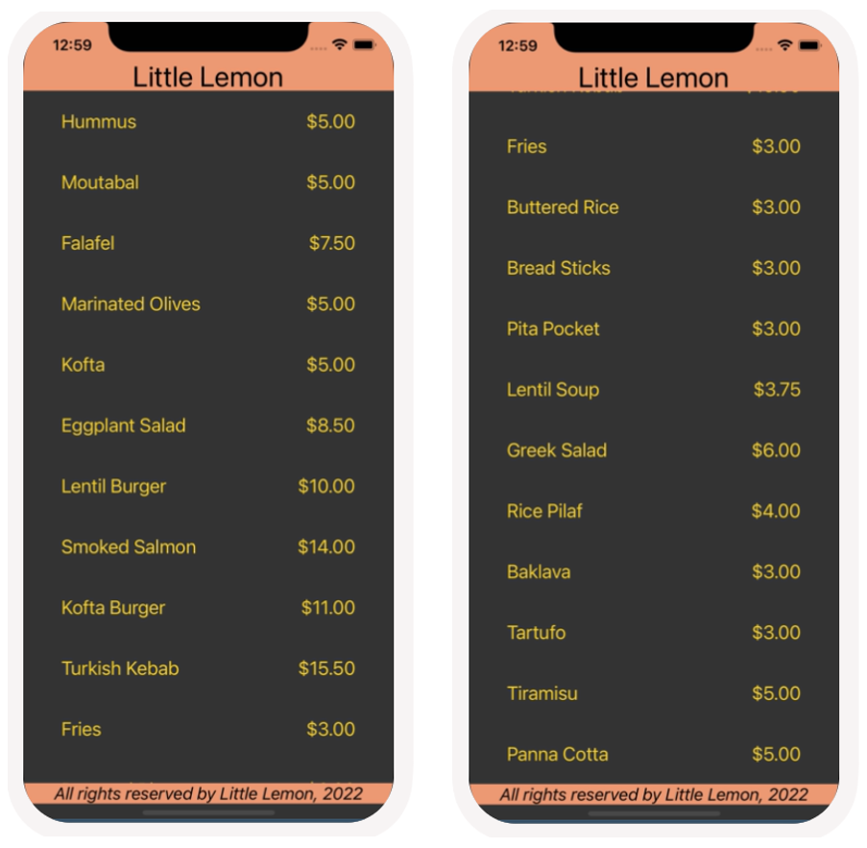

Procedure
Next, review the breakdown of the individual steps below.

Step 1: Create a component to display menu items and use FlatList
Create a new file for the menu component. You can name it MenuItems.js. Place the file within the components folder as follows: components/MenuItems.js
Within the component, render the FlatList component and pass to it the array from the scenario as shown below.
import React from 'react';

import { View, Text, FlatList } from 'react-native';

// Array provided in exercise scenario
const menuItemsToDisplay = [
{ name: 'Hummus', price: '$5.00', id: '1A' },
{ name: 'Moutabal', price: '$5.00', id: '2B' },
{ name: 'Falafel', price: '$7.50', id: '3C' },
{ name: 'Marinated Olives', price: '$5.00', id: '4D' },
{ name: 'Kofta', price: '$5.00', id: '5E' },
{ name: 'Eggplant Salad', price: '$8.50', id: '6F' },
{ name: 'Lentil Burger', price: '$10.00', id: '7G' },
{ name: 'Smoked Salmon', price: '$14.00', id: '8H' },
{ name: 'Kofta Burger', price: '$11.00', id: '9I' },
{ name: 'Turkish Kebab', price: '$15.50', id: '10J' },
{ name: 'Fries', price: '$3.00', id: '11K' },
{ name: 'Buttered Rice', price: '$3.00', id: '12L' },
{ name: 'Bread Sticks', price: '$3.00', id: '13M' },
{ name: 'Pita Pocket', price: '$3.00', id: '14N' },
{ name: 'Lentil Soup', price: '$3.75', id: '15O' },
{ name: 'Greek Salad', price: '$6.00', id: '16Q' },
{ name: 'Rice Pilaf', price: '$4.00', id: '17R' },
{ name: 'Baklava', price: '$3.00', id: '18S' },
{ name: 'Tartufo', price: '$3.00', id: '19T' },
{ name: 'Tiramisu', price: '$5.00', id: '20U' },
{ name: 'Panna Cotta', price: '$5.00', id: '21V' },
];

// Component to render name and price per item
const Item = ({ name, price }) => (
<View>
<Text>{name}</Text>
<Text>{price}</Text>
</View>
);

const MenuItems = () => {
const renderItem = ({ item }) => <Item name={item.name} price={item.price} />;

return (
<View>
<FlatList
data={menuItemsToDisplay}
keyExtractor={(item) => item.id}
renderItem={renderItem}></FlatList>
</View>
);
};

export default MenuItems;

Step 2: Style the component
Once you have coded a working component, it is time to style it. Apply the style props below to update the MenuItems component to match the screenshots.
import React from 'react';

import { View, Text, StyleSheet, FlatList } from 'react-native';

const menuItemsToDisplay = [
{ name: 'Hummus', price: '$5.00', id: '1A' },
{ name: 'Moutabal', price: '$5.00', id: '2B' },
{ name: 'Falafel', price: '$7.50', id: '3C' },
{ name: 'Marinated Olives', price: '$5.00', id: '4D' },
{ name: 'Kofta', price: '$5.00', id: '5E' },
{ name: 'Eggplant Salad', price: '$8.50', id: '6F' },
{ name: 'Lentil Burger', price: '$10.00', id: '7G' },
{ name: 'Smoked Salmon', price: '$14.00', id: '8H' },
{ name: 'Kofta Burger', price: '$11.00', id: '9I' },
{ name: 'Turkish Kebab', price: '$15.50', id: '10J' },
{ name: 'Fries', price: '$3.00', id: '11K' },
{ name: 'Buttered Rice', price: '$3.00', id: '12L' },
{ name: 'Bread Sticks', price: '$3.00', id: '13M' },
{ name: 'Pita Pocket', price: '$3.00', id: '14N' },
{ name: 'Lentil Soup', price: '$3.75', id: '15O' },
{ name: 'Greek Salad', price: '$6.00', id: '16Q' },
{ name: 'Rice Pilaf', price: '$4.00', id: '17R' },
{ name: 'Baklava', price: '$3.00', id: '18S' },
{ name: 'Tartufo', price: '$3.00', id: '19T' },
{ name: 'Tiramisu', price: '$5.00', id: '20U' },
{ name: 'Panna Cotta', price: '$5.00', id: '21V' },
];

const Item = ({ name, price }) => (
<View style={menuStyles.innerContainer}>
<Text style={menuStyles.itemText}>{name}</Text>
<Text style={menuStyles.itemText}>{price}</Text>
</View>
);

const MenuItems = () => {
const renderItem = ({ item }) => <Item name={item.name} price={item.price} />;

return (
<View style={menuStyles.container}>
<FlatList
data={menuItemsToDisplay}
keyExtractor={(item) => item.id}
renderItem={renderItem}></FlatList>
</View>
);
};

// Add styles to the component
const menuStyles = StyleSheet.create({
container: {
flex: 1,
},
innerContainer: {
paddingHorizontal: 40,
paddingVertical: 20,
flexDirection: 'row',
justifyContent: 'space-between',
},
itemText: {
color: '#F4CE14',
fontSize: 20,
},
});

export default MenuItems;

Step 3: Render the component from App.js
import * as React from 'react';
import { View, StyleSheet } from 'react-native';

import LittleLemonHeader from './components/LittleLemonHeader';
import LittleLemonFooter from './components/LittleLemonFooter';
import MenuItems from './components/MenuItems';

export default function App() {
return (
<>
<View style={styles.container}>
<LittleLemonHeader />
<MenuItems />
</View>
<View style={styles.footerContainer}>
<LittleLemonFooter />
</View>
</>
);
}

const styles = StyleSheet.create({
container: {
flex: 1,
backgroundColor: '#333333',
},
footerContainer: { backgroundColor: '#333333' },
});

The final step is to render MenuItems component, so that it appears on the emulator’s screen. To do this, make sure to render the MenuItems component from the App component as shown below:

